**Expressions of Interest**

**Package:** P-T5109 Fixed Mast Aerial Work Platform

**Preamble:**

SDP is requesting interested parties to submit prequalification documents for the supply of a fixed mast aerial work platform to be utilized in a specialized application. Details below.

**Scope of Work:**

Supply of fixed mast aerial work platform which will meet all of the parameters specified below. In addition to the supply of the unit, successful bidder will be required to provide on site training detailing the proper setup, take down and day to day maintenance and use of the equipment. Training can be conducted on an as needed basis or preferably provide a “train the trainer” program which will allow us to train our personnel as required.

Vendor may be required to come to site to perform repairs and maintenance as required/recommended during the life of the unit.

**Material Supply:**

* SDP to supply any required concrete anchors & adhesives for tie-in to the concrete structure.
* All other components required for the setup, use and maintenance of the mast climber shall be supplied by vendor.
* Vendor to also provide spare parts for the unit for wear and tear items

**Mandatory Requirements:**

Interested parties must be able to satisfy the following parameters:

1. The aerial work platform unit must be compliant with any applicable CSA code requirements or relevant ANSI codes. Vendor to supply code compliance for the unit for review;
2. Product shall include PEGNL stamped engineering drawings for setup and use in the Province of Newfoundland;
3. Unit will need to be compatible to be installed on curved walls. (60m radius and 11m radius);
4. Unit should be capable of raising a max. 45m in height with anchors;
5. Weight capacity of unit shall be minimum 750lbs to allow for 2 persons plus tools;
6. Each component of the unit shall be less than 100lbs for manual lifting;
7. Product will be required to fit through a round hatch opening with dimensions shown below:

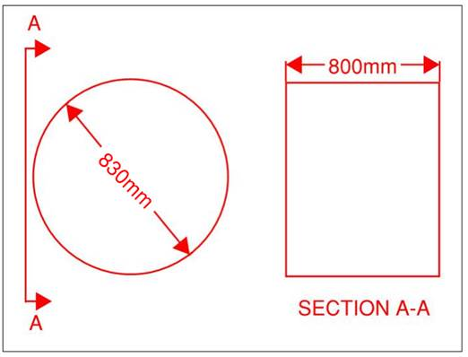

Optional Items:

1. Provide typical anchoring details for securing the unit to the concrete structure
2. Mast climbing unit needs to be intrinsically safe for use inside of a confined space.
3. Length of platform is required to be minimum 3m but longer platforms which can meet the above parameters would be considered an asset.

Additional info:

1. 1 unit required
2. Unit to be installed and operated vertically on concrete walls. Floor surface is level concrete base slab.

Responses to this EOI posting will register individual companies with the Project. Companies who have previously registered or been pre-qualified for this Project are asked to submit response to this EOI to ensure inclusion on the Bidders List. Joint venture proposals will be acceptable for Pre-qualification and should be clearly stipulated in the response to this EOI with details of JV Companies.

Closing date of this expression of interest is September 29, 2023 at 2:00pm NL Time.

EOI Responses to be forwarded to [procurement@sdpgp.ca](mailto:procurement@sdpgp.ca).